C. Close Fiscal Year YYYY
If you’re menu has “C. Close Fiscal Year 1” or another number other than the year, please call support and we will fix it.

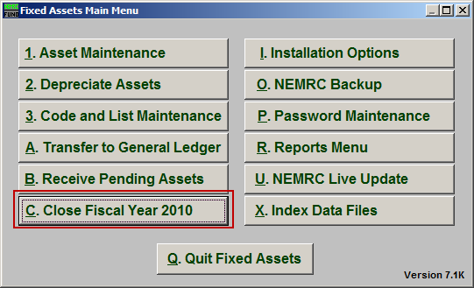
Click on “C. Close Fiscal Year YYYY” from the Main Menu and the following window will appear:

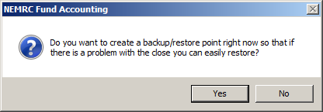
You should choose “Yes” to create a restore point. It may take a few minutes, and you will be notified when the restore point was created successfully. The following window will appear:

Close Fiscal Year YYYY

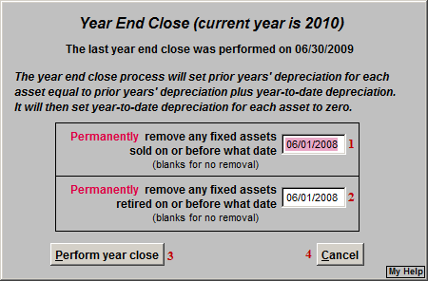
- Permanently remove any fixed assets sold on or before what date: The User can remove fixed assets sold on or before a date, the default is two years OR leave blank for no removal.

- Permanently remove any fixed assets retired on or before what date: The User can remove fixed assets retired on or before a date, the default is two years OR leave blank for no removal.

- Perform year close: Click this button to perform the year end task.

- Cancel: Click “Cancel” to cancel and return to the previous screen.

You may wish to wait until after your audit is completed to close the 2010 year.

